Directive @for

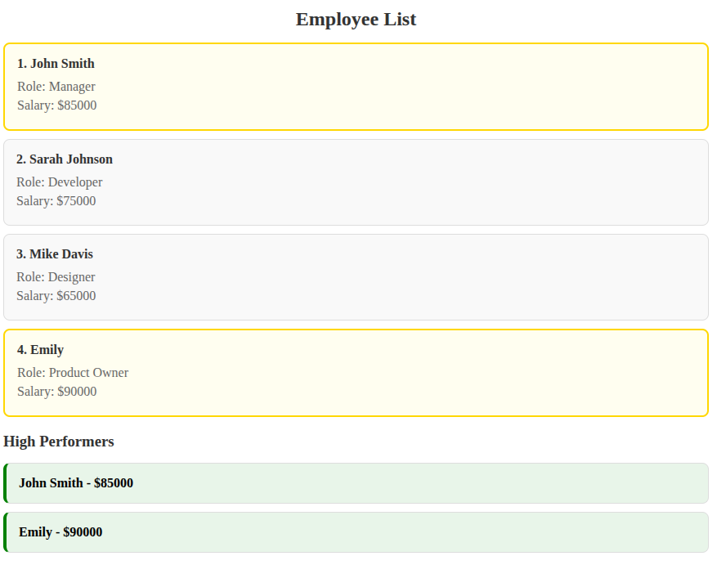

យើងចង់បង្ហាញ index for each element :
@for(employee of employees;
track employee.id;
let idx = $index;

){
<div class="employee-card" [class.high-salary]="employee.salary > 80000" >
<h4>{{idx +1}}. {{employee.name}}</h4>
<p>Role: {{employee.role}}</p>
<p>Salary: ${{employee.salary}}</p>
</div>
}
}

- let idx = $index ($index is the special keyword in the Angular that keep tracking the index)

@for(employee of employees;
track employee.id;
let idx = $index;
let isFirst = $first;
let isLast = $last;
let isEven = $even)

- $first : first element in the loop, $last : last element in the loop, $even :

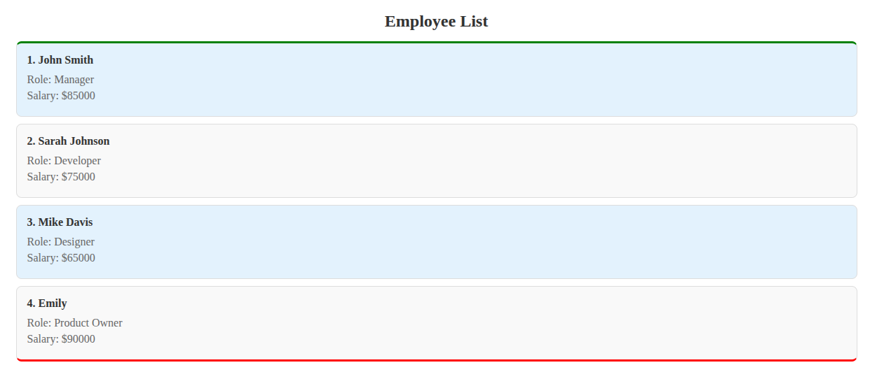

@for(employee of employees;
track employee.id;
let idx = $index;
let isFirst = $first;
let isLast = $last;
let isEven = $even
){
<div class="employee-card"
[class.first-employee]="isFirst"
[class.last-employee]="isLast"
[class.even-row]="isEven"
>
<h4>{{idx +1}}. {{employee.name}}</h4>
<p>Role: {{employee.role}}</p>
<p>Salary: ${{employee.salary}}</p>
</div>
}

- បើលេខ index វាជាលេខ គូវាបើប្រាស់ class មួយ៾ :[class.even-row]
- បើវា ជា first element it will use class: first-employee
- បើវា ជា last element it will use class: last-employee

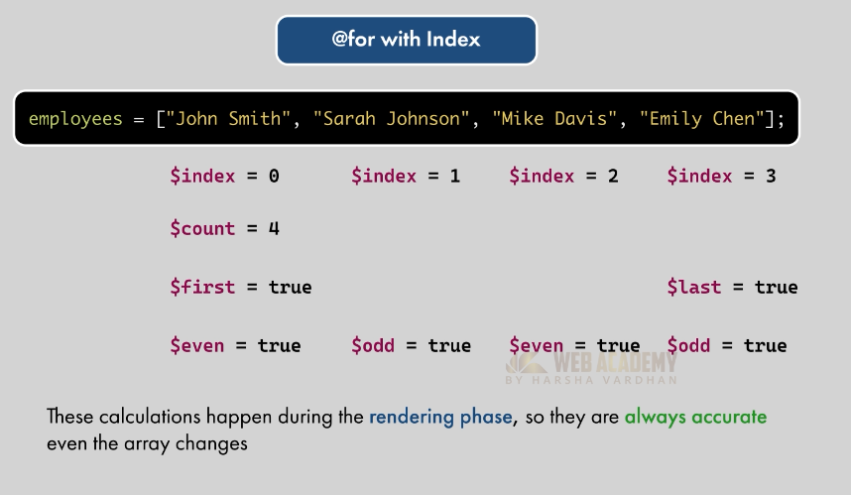

- $count


let count = $count;

<p><small>{{idx +1}} of {{count}} employees</small></p>
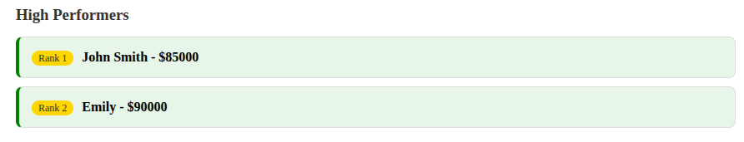

<h3>High Performers</h3>
@for(performer of getHightPerformers();
track performer.id;
let idx =$index
){
<div class="employee-card high-performer">
@if(idx < 3){
<span class="rank-badge">Rank {{idx + 1}}</span>
}
<strong>{{performer.name}} - ${{performer.salary}}</strong>
</div>
}
</div>

- Using method to control the @switch
TS:
getPerformanceLevel():string{
const percentage = (this.salesValue / this.targetValue) * 100;
if(percentage < 50) return 'poor';
else if (percentage <= 100) return 'average';
else return 'excellent';
}
HTML:

@switch (getPerformanceLevel()) {
@case ('poor') {
<div>
Performance needs immediate attention.
</div>
}
@case ('average') {
<div class="alert-warning">
Performance is accepable but could improve.
</div>
}
@case ('excellent') {
<div class="alert-success">
Outstanding performance! Keep it up.
</div>
}
@default {
<div>Performance status unknow</div>
}
}

